***Etude 04 – StrangeDays***

**Interface 1:**

In this speculative world, the population is striving for sustainability. Sustainability is a central theme for a good relationship between humans and nature. This theme is rising in the fashion design field. Because fabric waste is an important cause of environmental issues, companies and designers have developed sustainable, regenerative fabric. Every fabric-based accessory, shoe, and clothes will have a lifetime of 20 years. This product is based on the plant regeneration process. The material is made of perennial plant fibers. When the fashionable piece starts to be worn (i.e., holed, snagged, faded, wrinkled, etc.), its regenerative feature will fix those imperfections. To keep everything in place, microelectronic spiders contained within the piece will polish this regeneration through their web-making ability. Fabric's regenerative feature activates through movements and the users' body temperature; electronic spiders activate through heat. The material needs to stretch to fix those imperfections properly.  Those mechanical spiders will detect which area needs to be polished through their sensors. Once its lifetime is done, users can put the piece in compost due to having all the components and features biodegradables. Every company and fashion designers now use this type of fabric, which reduces the number of pieces created and the consumption and production of cloth. Plants will play a role of companionship in this product. Plants are helping humans to protect nature by taking advantage of their biological features. Plant regeneration allows humans to create sustainable alternatives.

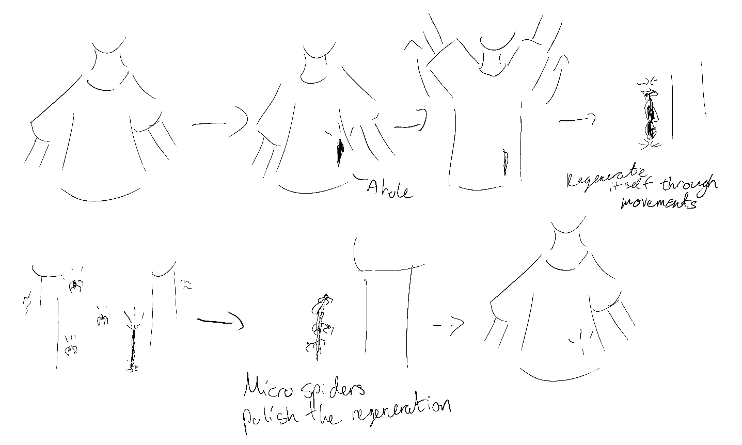

**Interface 2:**

In this speculative world, zero waste measures have been established. Companies, governments and citizens found creative methods to reduce overconsumption waste. The Venus Flytrap Vacuum is a machine in which a giant venus flytrap plant is connected to a generator. Each time the plant is eating waste, the waste is contained in the generator to convert it into electricity. The plant reacts each time it enters into contact with waste; it will automatically eat it. The device is connected to a phone app in which users can check multiple things: how much waste has been ingested, how much electricity has been produced, how much unused electricity is left in the generator; turn the machine on and off, checking if there is no more waste to ingest, etc. Multiple container sizes are offered for this device. Once the generator’s capacity is full, the users will receive a notification and need to press the button that allows the waste conversion into electricity on their app.  The produced electrical energy will serve in any electrical means, whether in a house, a mall, a restaurant, a local store, etc.  This machine creates a collaborative relationship between plants and humans. The plant will reduce waste and produce helpful energy for humans while feeding itself.